**UX-Design Documentation**

**Project Management Plan**

# Test Plans

The implemented solution was tested against different test plans to effectively understand the project outcomes depending on what was expected. Some of the expectations were the ease of login as a user who is registered in the system, ability to join a project or a task that is on going and gain a role as a user in a project for the ease of collaboration and others. The project allows the user to create new tasks as the owner of a task, address on the deadlines of given tasks, mark project as completed and others depending on the project specifics. The tool allows collaboration and task management for different team members.

## Test Case T001

User Login

|  |  |  |
| --- | --- | --- |
| Test Step | Expected Outcome | Actual Outcome |
| 1. Enter valid credentials | Successful login | User is able to login successfully |
| 2. Attempt login with wrong credentials | Authentication failure | System asks the users to enter valid login details |
| 3. Login with incomplete information | Authentication failure | System asks users to enter valid login details |

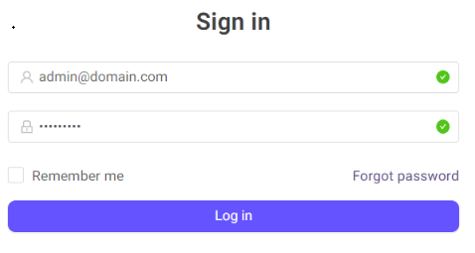

## Test Case T002

Create New Task with Details

|  |  |  |
| --- | --- | --- |
| Test Step | Expected Outcome | Actual Outcome |
| 1. Create a new task | Task creation successful | User is able to create a new task in the system |
| 2. Set task deadlines | Deadlines are properly set | User customizes the tasks by setting deadlines to the tasks without an error. |
| 3. Add task description | Task description added successfully | Task description is added by the user well without issues. |
| 4. Define task milestones | Milestones are set appropriately | Project milestones are able to get defined by the user. |
| 5. Update task progress | Task progress updated as expected | A user is able to update the project progress using percentage methods |

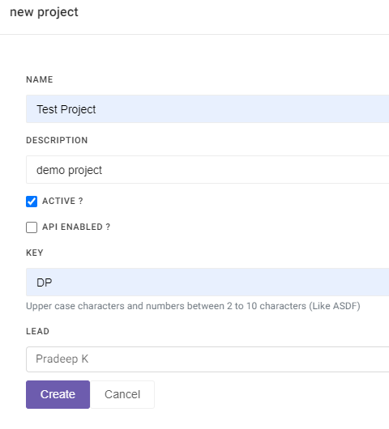

Figure Creating a New Task

The figure above shows the creation of a new project in the project management tool. In creating a new project, the users are able to update the project descriptions easily and update a task.

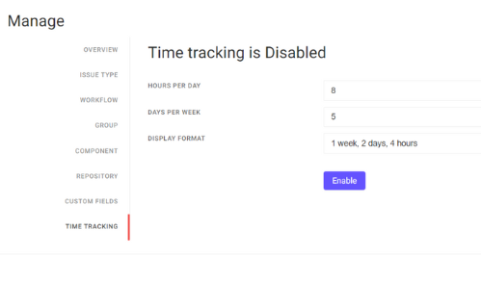

Figure Time Tracking

Time tracking is important to understand the progress of the project and this phase was well implemented to ensure that users can keep track of a project created.

## Test Case T003

Join a Team

|  |  |  |
| --- | --- | --- |
| Test Step | Expected Outcome | Actual Outcome |
| 1. Browse available teams/projects | View a list of available teams/projects | A user is able to browse on available projects. |
| 2. Select a team to join | Successfully join the selected team | A user is able to select a team to join |
| 3. Confirm membership status | Membership status updated as expected | A project membership is confirmed by the project owner prior to joining a project. |

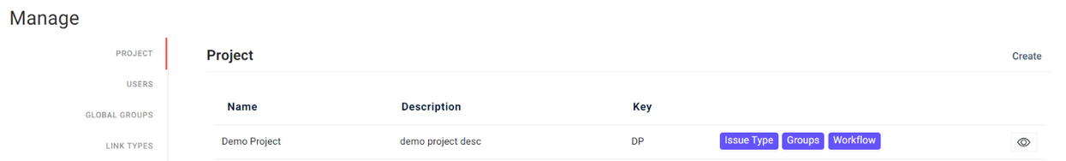

Figure Project Groups and Teams

The figure above shows the project groups where a user can join a project managed by other users easily and become a contributor in the project implementation process.

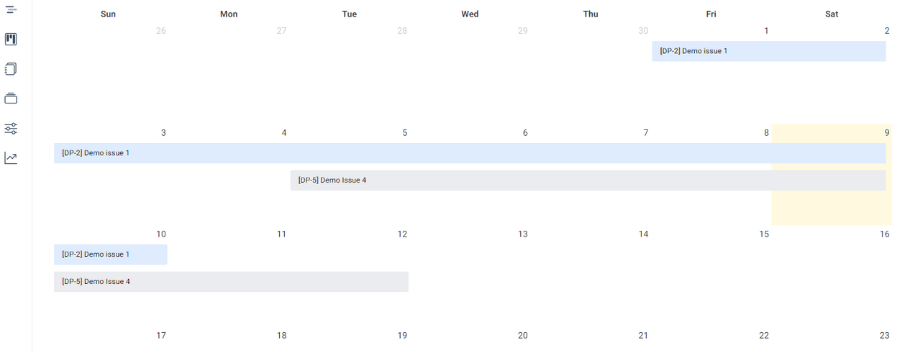

Figure Calendar view

The figure above shows the project calendar view to allow the users to view all the sections of the projects in a calendar view. It makes it easier to understand the project dates well.

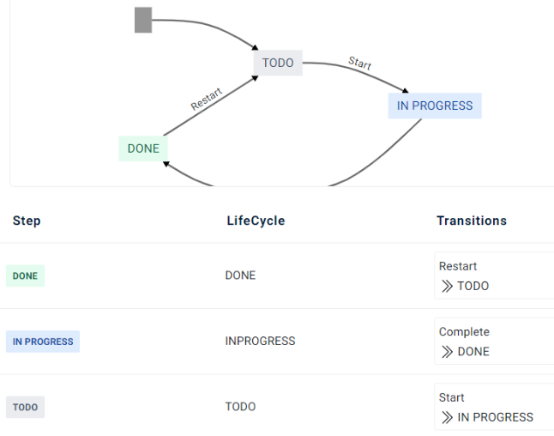

Figure done, to-do, in-progress

In order to effectively understand the current projects progress and tasks, we use a simpler visualization which helps in showcasing the current completed projects. The projects can get completed based on the timeframe set and updates by the team members. The TODO projects are the current running that have not been started. The in progress are projects which have partially completed parts.

# Report

The test phases were conducted to evaluate the possibilities of errors and failures in the project and create a future gap for updates. The common functionalities dealt with included the general operation of a task management and project management with collaboration among team members and was successful. Some of the sections that might have needed more updates includes the following:

**Login and registration:** The login section only allows the direct registration process and does not involve the use of login with Facebook, google or other methods. This could be a limitation to the project and needs future updates to allow members to update the details and login directly with google or Facebook for efficiency in authorization. The project proves a higher reliability in the production level.

**User Feedback:** User feedback system is something that have not yet been implemented in the project and might pose a need to implement. Users should be able to give their personal feedback on a project during a project progress (Suci & M., 2019). This is a project Gap that will get implemented with time.

In conclusion, the project demonstrated high level and strong support on the recent technologies in implementation. Some of the approaches applied includes the use of Postgres database for the storage of the schedules and data from the application (Ana & Vlado, 2020). We applied java spring for the UX design and also the backend design. Other styling scripts were incorporated to ensure the project is rich in design.

# Recommendations

The recommendations on the future of the project implementation would be to consider the security measures of the system. At the time being, we only performed general regression testing on the system and the system usability. The general system usage comprises of the capability to offer general system authorization, create and manage tasks depending on the user role.

In the option of authorization, there are new approaches to security password hashing with known possibilities of attack and cracking. We applied the use of MD5 Hashing method with salt to secure the passwords for the user (Matthew, 2022). A secure system needs a password management policy so as to ensure that the production team maintains the security of the project progress.

Another aspect I would recommend to consider in future of the implemented project is the integration of machine learning and artificial intelligence in some of the parts. Example, there would be an easy chat system which is automated in cases of issue reporting in the project (Mohammed, et al., 2021). The system should learn the common algorithms implemented in the system and when an issue arises, it can easily be delt with automatically without having to involve technical team.

# References

Ana, M., & Vlado, M. (2020). Practical application of contemporary project management software. *Annals of DAAAM and Proceedings of the International DAAAM Symposium*. doi:10.2507/31st.daaam.proceedings.119

Matthew, M. (2022). Hashing and Salting of Passwords. *Pro Encryption in SQL Server 2022*. doi:10.1007/978-1-4842-8664-7_19

Mohammed, N. M., Mohd, H. M., Abdul, R. A., Roslan, I. Y., Lim, K. C., Muhammad, S. ,., . . . Hushalini, H. ,. (2021). Software project management using machine learning technique-a review. *Applied Sciences*. doi:10.3390/app11115183

Suci, M., & M., S. (2019). Utilizing project management software in project scheduling: A case study. *IOP Conference Series: Materials Science and Engineering*. doi: 10.1088/1757-899X/528/1/012037